Add a web form to index.html as shown below that allows the user to enter personal information for joining a social network. The webpage uses CSS to align the form widgets vertically.

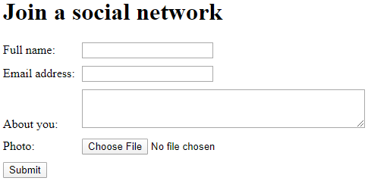

The form should:

* Use the POST method and the "multipart/form-data" enctype
* Submit to
* Use a <label> for each form field and the label text shown in the image above
* Use a <div> to surround each label and form widget and a <div> around the submit button
* Use a text <input> with name and id "fullName" to get the user's name
* Use a text <input> with name and id "email" to get the user's email address
* Use a <textarea> with 3 rows, 50 columns, and name and id "about" to get a short description about the user
* Use a text <input> with type "file" and name and id "picture" to get the user's image
* Use a submit <input> button
* Use the required attribute for name and email fields